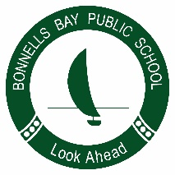
Bonnells Bay Public School
Safe, Respectful, Engaged Learners

Easter Hat Parade Supplies Request

8 March 2019

Dear Parents and Carers,

On Tuesday, 9 April 2019, classes across the school will be making their hats for the Easter Hat Parade which will be held on Thursday, 11 April. This year, hats will be made in class during the middle session from 12:30pm until 2pm.

Bonnells Bay Public School is supplying the cardboard, paint and other various art supplies for the making of these hats, however we are asking families if they could donate extra supplies to the school to make our hats extra special. The items brought in would be shared between all the students in your child’s class.

Below is a list of art and craft supplies that would be useful in the making of our hats.
- Cotton balls
- Pipe cleaners
- Easter stickers/paraphernalia
- Ribbon
- Feathers
- Pom poms

Your help in donating the above listed supplies is greatly appreciated. Do keep in mind that we are not picky, and anything brought in will be happily put to use. Furthermore, the above list shows examples of items to bring in, but feel free to donate anything you think we could use in the creation of our hats.

Thank you.
Brooke Titterton

