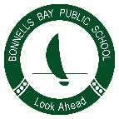
Bonnells Bay Public School

Newsletter Options

Family Name: _______________________________________________________________________

Children at School: ___________________________________________________________________

- Please have a paper copy of the newsletter sent home each week
- Please email me a copy of the newsletter each week. .

My email address is: _________________________________________________________________

Parent/Caregiver’s Signature: ____________________________________ Date: _________________

