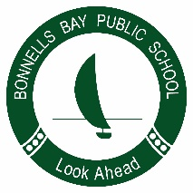
Bonnells Bay Public School
Safe, Respectful, Engaged Learners

8 April 2019

Dear Parents/Caregivers,

Unfortunately the response to our Stage 3 camp was less than expected based on past years. This has resulted in a $25 increase in the total cost of the camp. Reduced numbers has meant costs are distributed over a smaller number of students.

I sincerely apologise for this increase, however, having to book such an event 12 months in advance makes pricing difficult to assess.

This will mean that the final payment due 31 May, will now be $145.

If you have already paid the amount in full, the additional costing is due on 31 May 2019.

If this additional costing causes financial hardship, please contact the school office to obtain a Student Assistance Form and request funding assistance for the additional $25.

Regards,
Narelle Stokes
Assistant Principal S3

